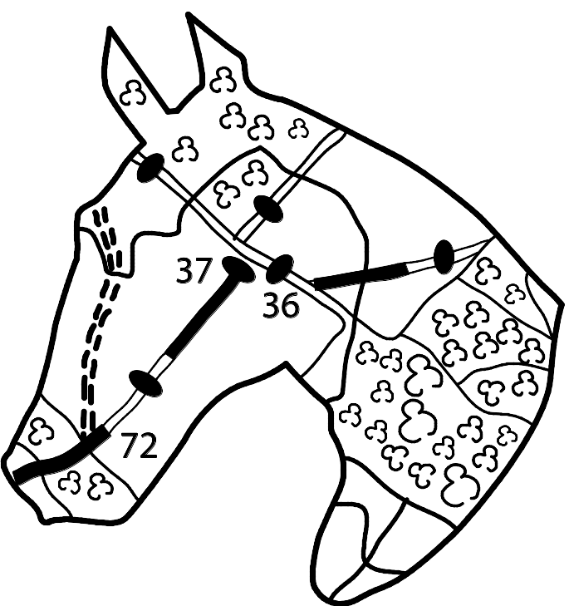

ESSEX
BRIDLEWAYS
ASSOCIATION
Registered Charity No. 801530
2020 Ride Schedule

www.essexbridleways.co.uk

28th February Flitch Way Friday – A Friday ride starting from Great Notley Park. We ride to L Dunmow along the hard surfaced track of a disused railway called the Flitch Way, do a little loop at the end; then ride back to Notley. 13 miles in total.

29th March Sunday Middlewick Farm Ride, Southminster – Lovely grassy tracks (some optional jumps), just a few quiet remote roads. Includes 3 mile shorter route.

Beach Ride Holiday Fri 17th-Sun19th April - Whitehall Farm Holkham Beach (members only). Still some room so please email lesleygggillman@hotmail.com if you want to come.

3rd May Sunday Spains Hall, Finchingfield – This came second favourite when you voted at the AGM so we have included it.. A nice ride on grassy tracks, hardly any road work.

6th June Saturday Hatfield Forest Ride, Bishops Stortford – A chance to ride in this wonderful ancient forest on wide grassy clearings and tracks between the trees.

27th June Saturday Weald Children/Novice Riders – 3 mile group rides suitable for children and novice riders on/off lead rein all within the park.

5th July Sunday Highwood Ride, near Chelmsford – a varied route which takes in the wide grassy tracks of Howletts Hall and Fingrith Hall. Oh so many canters.

16th August Sunday Ramsden Heath – The second time for this new ride exploring the bridleways around Ramsden Heath and South Hanningfield.

20th September Sunday Brent Pelham – This is a ride we did years ago and have included it again this year in celebration of a bridleway on the route being brought back into use. A lovely countryside route just over the border into Hertfordshire.

4th October Sunday Danbury – 12 miles of tracks, bridleways and some minor roads with a shorter option available. Also includes the optional cc course at Riffhams.

5th December Saturday Epping Forest Xmas Ride (members only) (TBC)- This is our Members-only Christmas ride on surfaced tracks in Epping Forest with Xmas fancy dress, mulled wine and mince pies.

2021 Thetford Forest Holiday – Fri 17th- Mon 20th September – our members only holiday at Little Lodge in the heart of Thetford Forest.
2020 Ride Schedule

ESSEX
BRIDLEWAYS
ASSOCIATION
Registered Charity No. 801530

www.essexbridleways.co.uk

28th February Flitch Way Friday – A Friday ride starting from Great Notley Park. We ride to L Dunmow along the hard surfaced track of a disused railway called the Flitch Way, do a little loop at the end; then ride back to Notley. 13 miles in total.

29th March Sunday Middlewick Farm Ride, Southminster – Lovely grassy tracks (some optional jumps), just a few quiet remote roads. Includes 3 mile shorter route.

Beach Ride Holiday Fri 17th-Sun19th April - Whitehall Farm Holkham Beach (members only). Still some room so please email lesleygggillman@hotmail.com if you want to come.

3rd May Sunday Spains Hall, Finchingfield – This came second favourite when you voted at the AGM so we have included it. A nice ride on grassy tracks, hardly any road work

6th June Saturday Hatfield Forest Ride, Bishops Stortford – A chance to ride in this wonderful ancient forest on wide grassy clearings and tracks between the trees.

27th June Saturday Weald Children/Novice Riders – 3 mile group rides suitable for children and novice riders on/off lead rein all within the park.

5th July Sunday Highwood Ride, near Chelmsford – a varied route which takes in the wide grassy tracks of Howletts Hall and Fingrith Hall. Oh so many canters.

16th August Sunday Ramsden Heath – The second time for this new ride exploring the bridleways around Ramsden Heath and South Hanningfield.

20th September Sunday Brent Pelham – This is a ride we did years ago and have included it again this year in celebration of a bridleway on the route being brought back into use. A lovely countryside route just over the border into Hertfordshire.

4th October Sunday Danbury – 12 miles of tracks, bridleways and some minor roads with a shorter option available. Also to include the optional cross country course at Riffhams.

5th December Saturday Epping Forest Xmas Ride (members only) (TBC)- This is our Members-only Christmas ride on surfaced tracks in Epping Forest with Xmas fancy dress, mulled wine and mince pies.

2021 Thetford Forest Holiday – Fri 17th- Mon 20th September – our members only holiday to Little Lodge in the heart of Thetford Forest.

More than just rides ….

ESSEX
BRIDLEWAYS
ASSOCIATION
Registered Charity No. 801530

Whilst our rides may be a lot of fun, EBA runs these to raise funds for our bridleways campaign work.

The Trustees, Area Representatives and other volunteers work hard behind the scenes to ensure the rights of horse-riders are taken into consideration. We fight to ensure that councils maintain our Bridleways, that they are kept in a good state of repair and that access is not restricted. We are informed of planning applications which affect public rights of way and diversion orders, to ensure that any changes will not have a detrimental impact on horse riders. We campaign for new Bridleways and encourage multi-user tracks to be incorporated at the planning stage, ensuring access for all users.

We also work to ensure that ‘lost’ bridleways are reclaimed. The saying ‘once a highway, always a highway’ drives much of our work in this area. We actively seek evidence that would enable us to make a claim for an existing route to be upgraded to bridleway status. This could be based on evidence from old maps, minutes of council meetings and evidence of usage by multiple people over a period of at least 20 years without challenge.

If you are not already a member please join us.

The more members we have the greater the impact that EBA can have. As a member you are supporting us to maintain existing bridleways and to build and develop a stronger network of routes.

Membership benefits include discounted entry on all of our rides and access to our ride and share scheme, enabling you to explore new routes across the county guided by one of our friendly volunteers. You’ll receive our EBA Update magazine twice yearly and have a designated area representative who can help you to resolve any issues with bridleways in your area.

To join online please visit our website www.essexbridleways.co.uk or for postal applications please send an SAE to Alison Craigmile, EBA Membership Secretary,
40 The Chase, Romford, Essex RM1 4BE

More than just rides ….

ESSEX
BRIDLEWAYS
ASSOCIATION
Registered Charity No. 801530

Whilst our rides may be a lot of fun, EBA runs these to raise funds for our bridleways campaign work.

The Trustees, Area Representatives and other volunteers work hard behind the scenes to ensure the rights of horse-riders are taken into consideration. We fight to ensure that councils maintain our Bridleways, that they are kept in a good state of repair and that access is not restricted. We are informed of planning applications which affect public rights of way and diversion orders, to ensure that any changes will not have a detrimental impact on horse riders. We campaign for new Bridleways and encourage multi-user tracks to be incorporated at the planning stage, ensuring access for all users.

We also work to ensure that ‘lost’ bridleways are reclaimed. The saying ‘once a highway, always a highway’ drives much of our work in this area. We actively seek evidence that would enable us to make a claim for an existing route to be upgraded to bridleway status. This could be based on evidence from old maps, minutes of council meetings and evidence of usage by multiple people over a period of at least 20 years without challenge.

If you are not already a member please join us.

The more members we have the greater the impact that EBA can have. As a member you are supporting us to maintain existing bridleways and to build and develop a stronger network of routes.

Membership benefits include discounted entry on all of our rides and access to our ride and share scheme, enabling you to explore new routes across the county guided by one of our friendly volunteers. You’ll receive our EBA Update magazine twice yearly and have a designated area representative who can help you to resolve any issues with bridleways in your area.

To join online please visit our website www.essexbridleways.co.uk or for postal applications please send an SAE to Alison Craigmile, EBA Membership Secretary,
40 The Chase, Romford, Essex RM1 4BE

